**DAILY ONLINE ACTIVITIES SUMMARY**

|  |  |  |  |  |  |  |  |
| --- | --- | --- | --- | --- | --- | --- | --- |
| **Date:** | **05/06/2020** | | | | **Name:** | **Sheetal** | |
| **Sem & Sec** | **8 B** | | | | **USN:** | **4AL16CS091** | |
| **Online Test Summary** | | | | | | | |
| **Subject** | | **BDA** | | | | | |
| **Max. Marks** | | **30** | | **Score** | | **16** | |
| **Certification Course Summary(Internship)** | | | | | | | |
| **Task** | **Study-Learning data analytics concepts with platform specified**  **POC- working on sathya sales dataset dashboard development and Testing for the POC done** | | | | | | |
| **Company** | | | **Gain Insights** | **Duration** | | | **9 hr** |
| **Coding Challenges** | | | | | | | |
| **Problem Statement:**  **1)**Write a Python program to convert seconds today, hour, minutes and seconds | | | | | | | |
| **Status:completed** | | | | | | | |
| **Uploaded the report in Github** | | | | **Yes** | | | |
| **If yes Repository name** | | | | [alvas-education-foundation](https://github.com/alvas-education-foundation)/ **[sheetal-shettigar](https://github.com/alvas-education-foundation/sheetal-shettigar)** | | | |
| **Uploaded the report in slack** | | | | **Yes** | | | |

ONLINE TEST

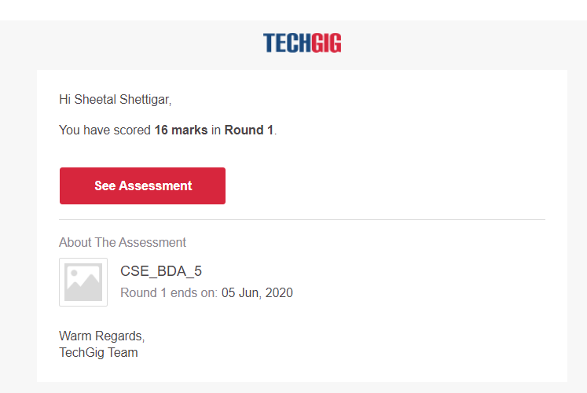

CODING CHALLENGE:

PROGRAM 1 :

time=float(input("Input time in seconds:") )

day=time

//(24*3600) time=time%(24*3600)

hour=time//3600

time%=3600

minutes=time

//60 time%=60

seconds=time print("day:->%d"%(day))

print("hour:->%d"%(hour))

print("minutes:->%d"%(minutes))

print("seconds:->%d"%(seconds))